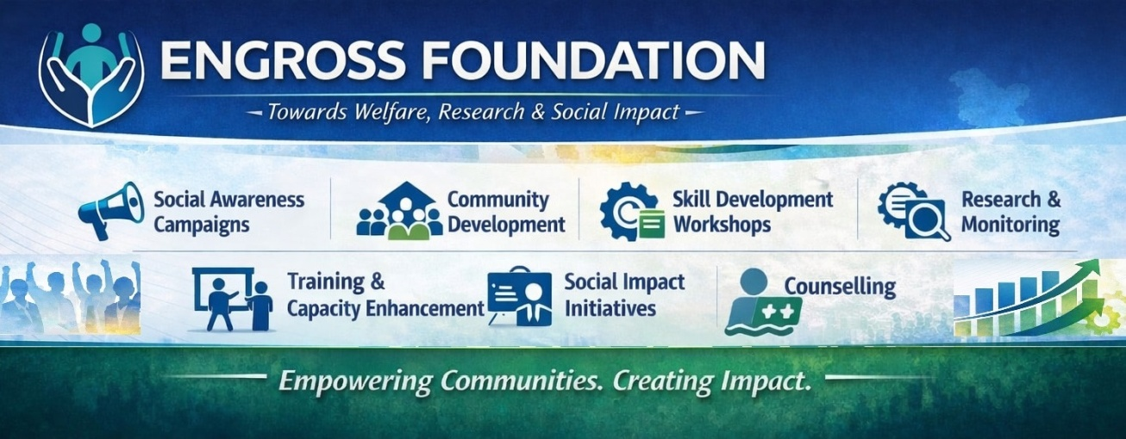
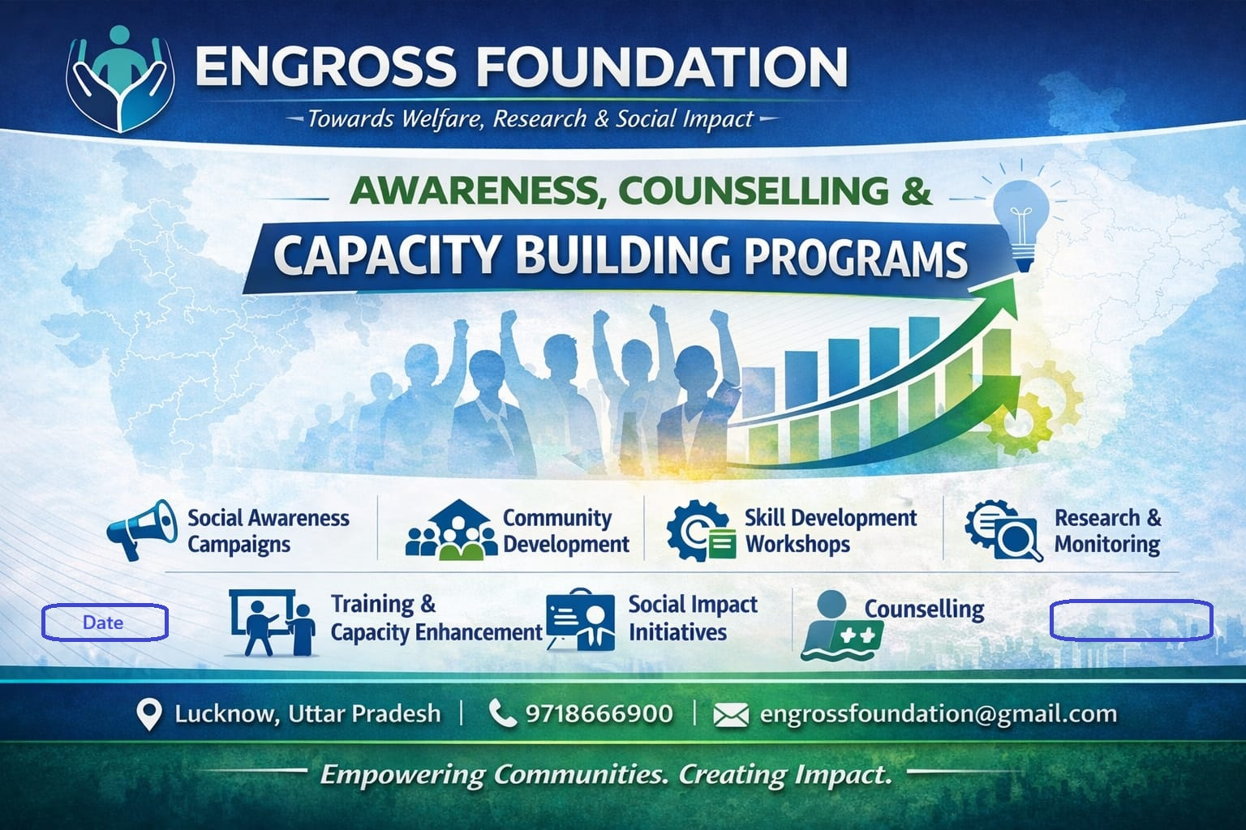
Registered Office- HN – 16 Satyam City, Dipti Khera, Para Ring Road Lucknow-226017 Opp RB Public School
Head Office- 207/14, Prakash Muhalla, East of Kailash, New Delhi-110065,
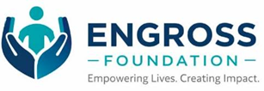
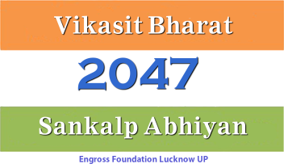
Recognised by MCA and NITI Aayog
Govt. of India
9001-2015 Certified Organisation
Email- engrossfoundation@gmail.com
Mobile -9718666900



Welfare Research Innovation LIVELIHOOD Training COUNSELLING Consulting

Date:

About Engross Foundation
Engross Foundation is a registered Indian Trust established by a team of highly qualified professionals with extensive experience in development practice and social innovation. The Foundation is committed to fostering inclusive and sustainable development through a multidimensional approach encompassing welfare, social service, research, education, training, and capacity building.
The organization works towards strengthening livelihoods, enhancing skills, and building community resilience, while actively promoting awareness of government policies and development programmes to ensure greater outreach and impact.
Engross Foundation’s key focus areas include health and hygiene, promotion of eco-friendly and organic practices, psychological support during disasters, post-disaster rehabilitation, and livelihood development for vulnerable and marginalized communities.
In addition, the Foundation provides research, consultancy, and technical support services to researchers, planners, and policymakers. Through evidence-based insights and strategic guidance, Engross contributes to improving the design, implementation, and overall effectiveness of developmental programmes and public policies.
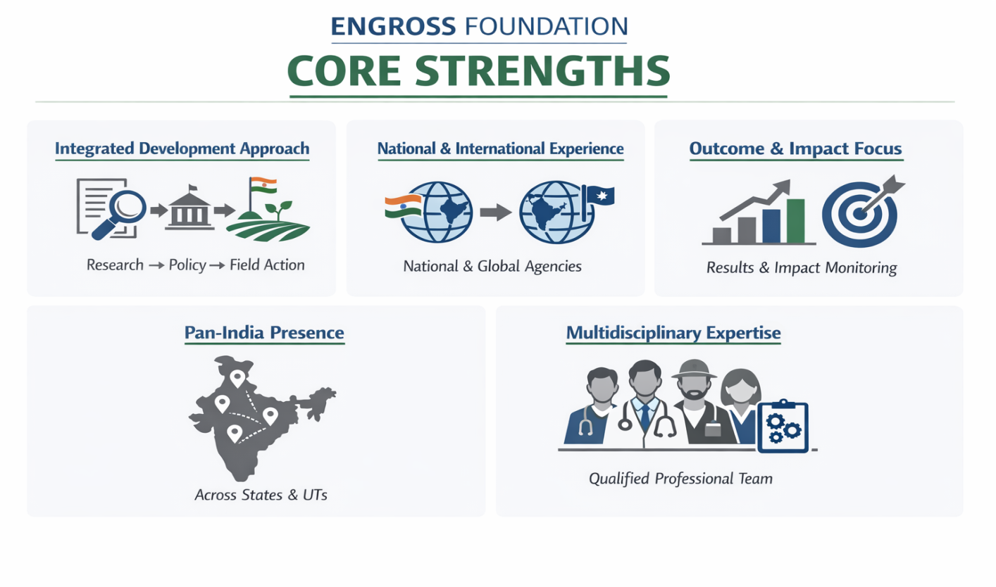

Vision
To build an inclusive and sustainable society anchored in research and evidence-based development, ensuring that every individual, particularly the vulnerable and marginalized, has equitable access to opportunities, resources, and support for a dignified life.

Mission
To promote inclusive and sustainable development through research-driven and evidence-based interventions that expand equitable access to opportunities, resources, and support systems. Engross Foundation is committed to strengthening livelihoods, enhancing skills, and building resilient communities—especially among vulnerable and marginalized groups—while generating actionable insights to improve development programmes and public policies.

Core Objectives
- Promote Research-Based Inclusive Development:
To design and implement development programmes grounded in research and evidence, ensuring equitable inclusion of vulnerable and marginalized communities.
- Enhance Livelihoods & Access to Opportunities:
To improve access to sustainable livelihoods, skills, and entrepreneurship through data-driven and market-oriented interventions.
- Strengthen Access to Resources & Support Systems:
To facilitate access to government schemes, institutional support, and essential services through awareness, outreach, and guidance.
- Build Community Resilience:
To strengthen the capacity of communities to respond to social, economic, and environmental challenges through evidence-based approaches and interventions.
- Promote Health, Hygiene & Well-being:
To improve public health outcomes through awareness programmes, preventive practices, and research-informed initiatives.
- Encourage Environmental Sustainability:
To promote eco-friendly practices, organic approaches, and sustainable resource management through community engagement and applied research.
- Capacity Building & Skill Development:
To empower individuals and institutions through training, workshops, and behavioural development programmes based on research and best practices.
- Research, Monitoring & Policy Support:
To conduct research, monitoring & evaluation, and impact assessments, and provide consultancy support to strengthen development programmes and policies.
- Knowledge Dissemination & Awareness:
To generate and share research-based knowledge, enhancing awareness, informed decision-making, and effective utilization of development initiatives.

Our Approach
At Engross Foundation, we follow a structured and people-centric approach to drive sustainable development and meaningful social impact. Our work is guided by collaboration, professional excellence, and a deep commitment to community empowerment.

Collaborative Partnerships
We build strong partnerships with government bodies, educational institutions, civil society organizations, and corporate stakeholders to design and implement impactful programs at scale.


Sustainable Engagement
Our initiatives are not short-term interventions. We focus on long-term engagement, ensuring continuity, trust-building, and lasting outcomes for communities.
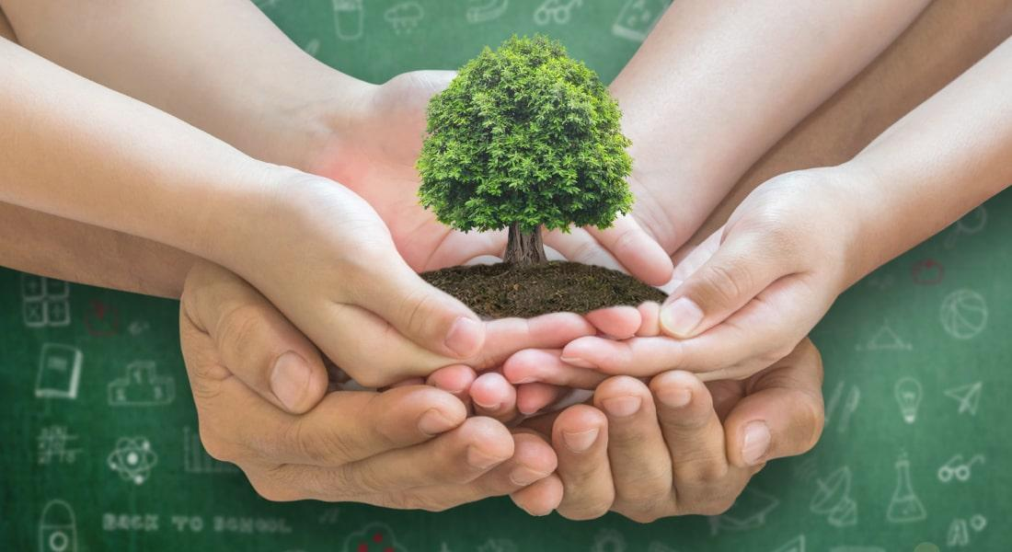

Professional and Ethical Leadership
Our team comprises experienced professionals from diverse fields including psychology, research, social development, and policy. We ensure ethical practices, transparency, and high-quality execution in every initiative.


Community-Centered
We place people at the heart of our work. Every program is designed based on real needs, ensuring inclusivity, participation, and cultural sensitivity.
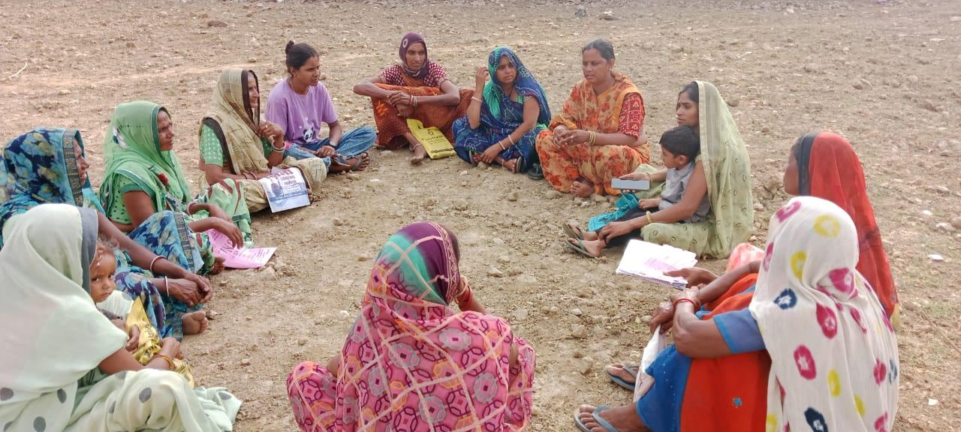

Empowerment & Self-Reliance
We believe in enabling individuals and communities to take charge of their own development by building skills, awareness, and institutional capacities.
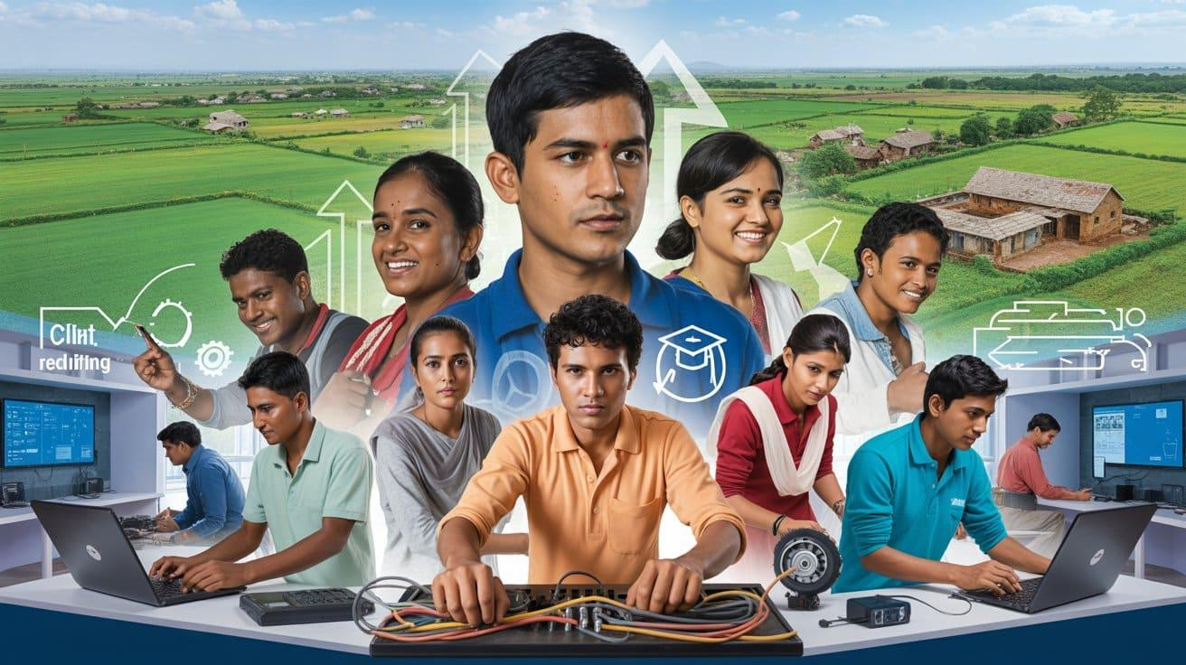

We Do
Engross Foundation works across multiple sectors to promote inclusive, equitable, and sustainable development through research-driven and evidence-based interventions. Our integrated approach focuses on strengthening communities, improving livelihoods, and supporting informed decision-making for long-term impact.

Research, Survey & Impact Assessment
We conduct rigorous research, baseline and endline surveys, and impact assessments to understand community needs and evaluate programme effectiveness. Our evidence-based insights support better planning, policy formulation, and implementation.
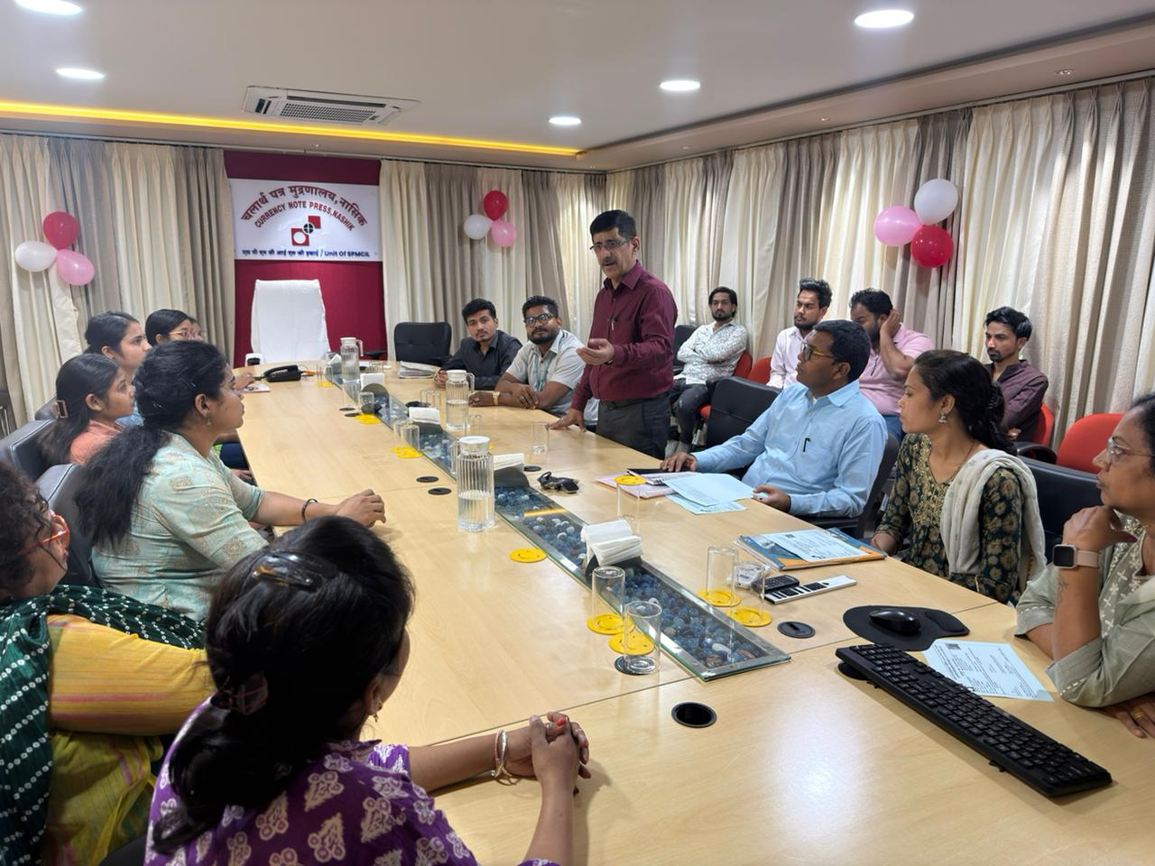

Livelihood & Economic Development
We promote sustainable livelihood opportunities by supporting skill-based employment, entrepreneurship, and micro-enterprises. Our initiatives aim to enhance income generation and economic resilience among vulnerable communities.

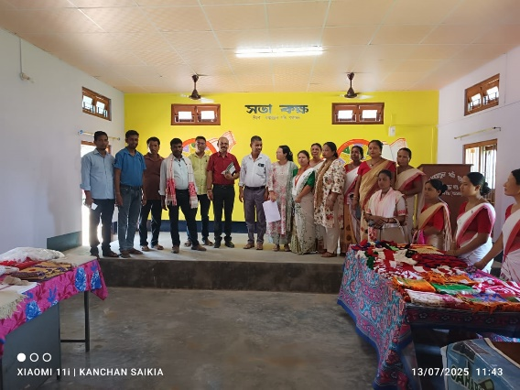

Skill Development & Capacity Building
We provide vocational training, employability skills, and capacity-building programmes for individuals and institutions. Our training interventions are designed to enhance skills, confidence, and long-term self-reliance.
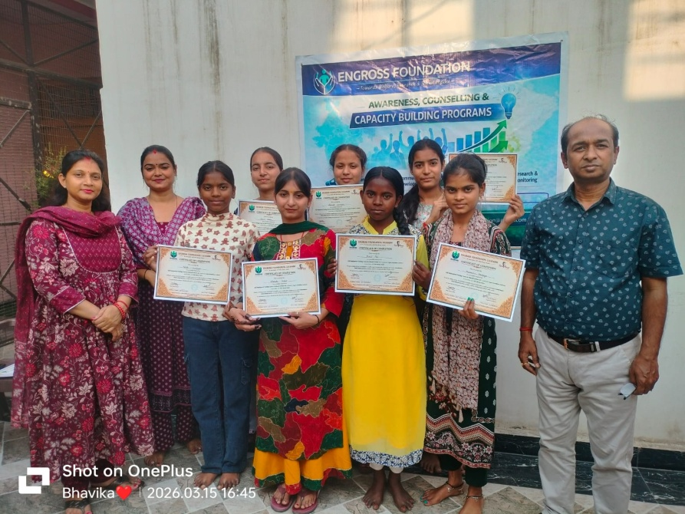

Health, Hygiene & Mental Well-being
We work to improve community health through awareness campaigns, preventive healthcare initiatives, and hygiene promotion. We also provide mental health and psychosocial support, especially during crisis situations.
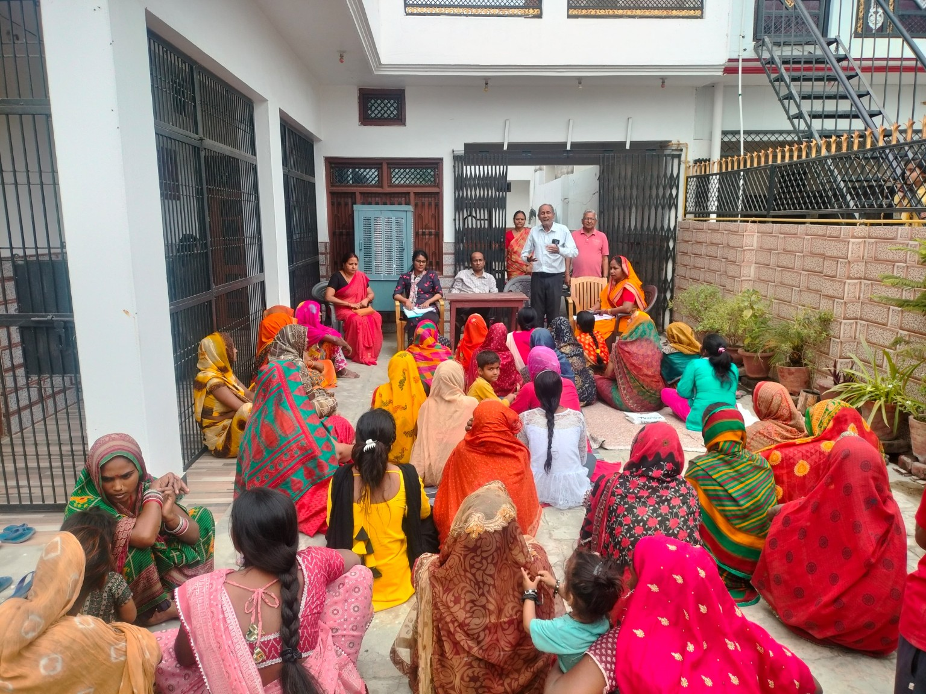

Disaster Management & Rehabilitation
Our disaster response initiatives include preparedness, emergency relief, psychological support, and post-disaster rehabilitation. We focus on building resilient communities capable of responding to and recovering from crises.
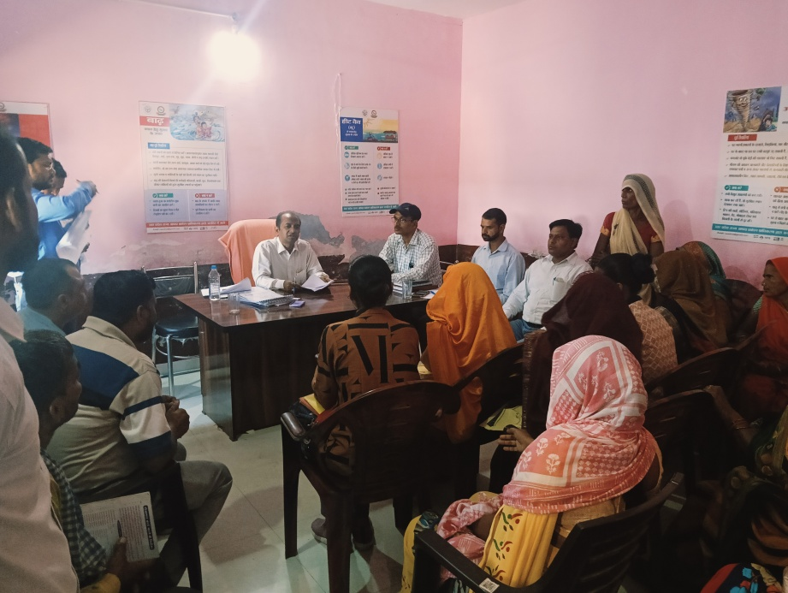

6. Social Welfare & Community Development
We implement welfare programmes aimed at empowering marginalized groups, including women, children, and youth. Our efforts focus on social inclusion, equity, and community participation.
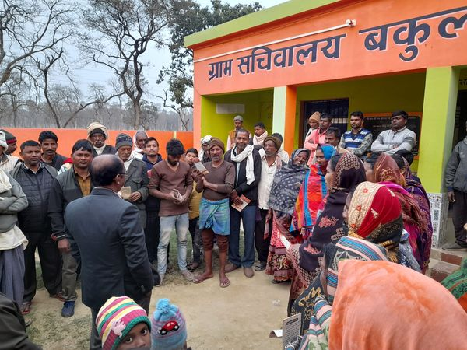

Awareness, Advocacy & Public Engagement
We conduct awareness campaigns and outreach programmes to promote government schemes, rights, and entitlements. Our advocacy efforts aim to bridge information gaps and enhance access to public services.

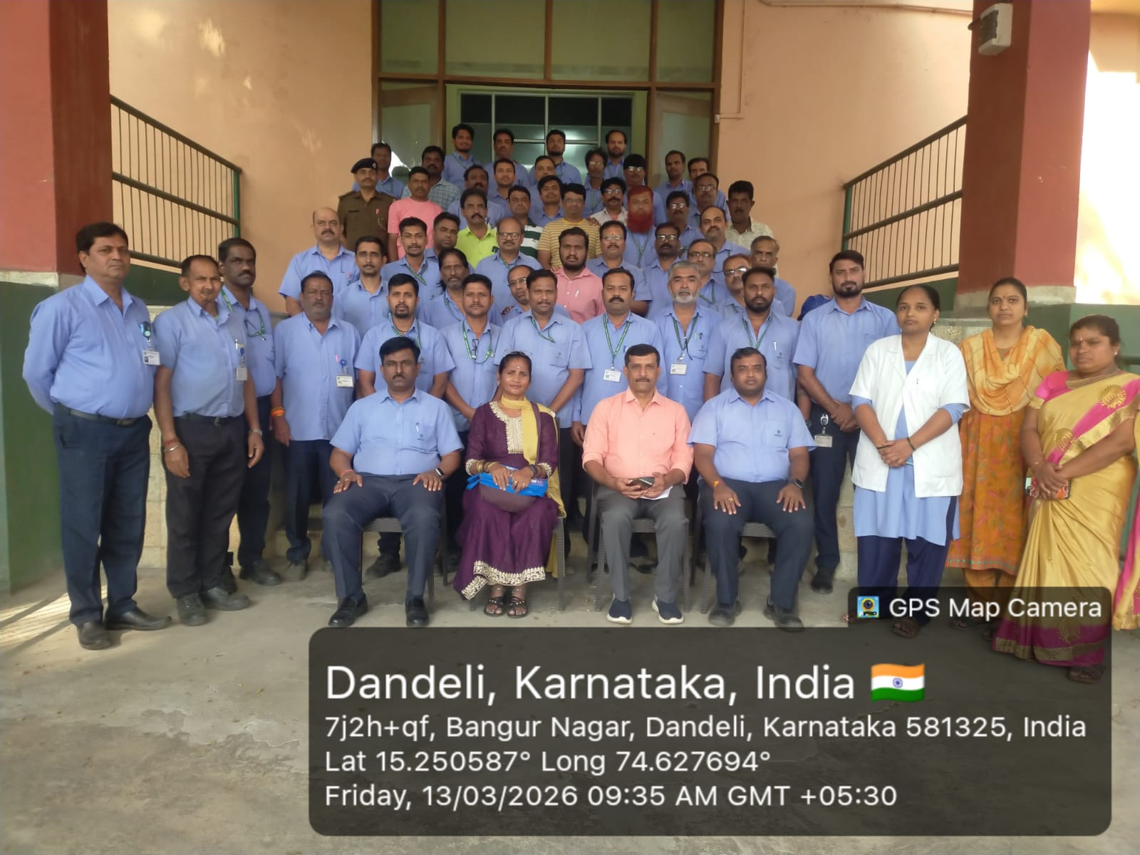

Environmental Sustainability & Organic Practices
We promote eco-friendly practices, organic farming, and sustainable resource management. Our initiatives encourage environmental conservation and climate-conscious community development.
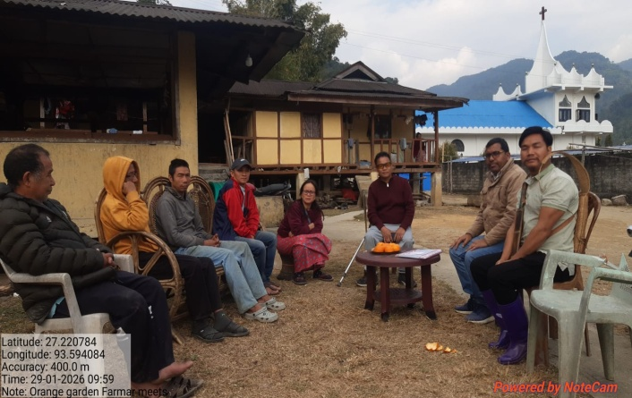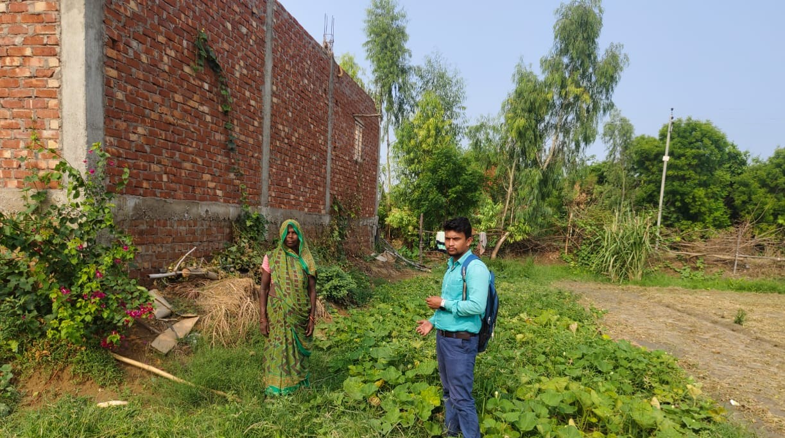

Monitoring, Evaluation & Policy Support
We provide monitoring and evaluation services, policy research, and technical consultancy to improve the effectiveness and impact of development programmes and public policies.
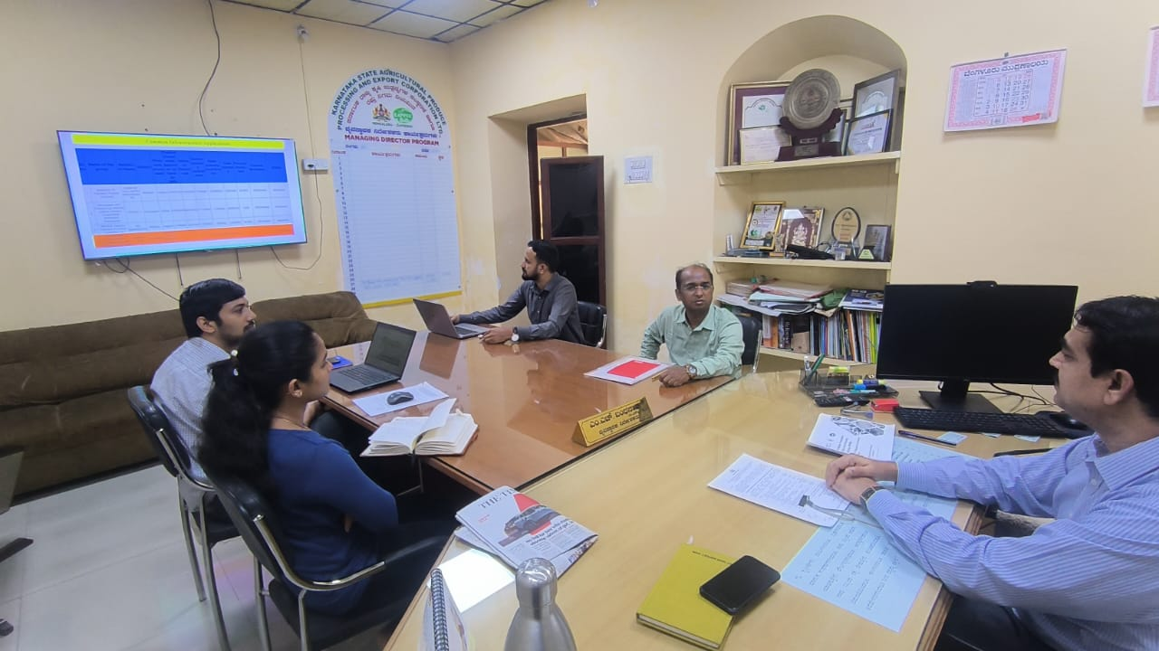

Our Approach
- Research and Evidence-Based Planning
- Community Participation and Inclusion
- Sustainability and Long-Term Impact
- Collaboration with Stakeholders and Institutions

Why It Matters
Through our multi-sectoral approach, Engross Foundation aims to create lasting change by empowering communities, strengthening systems, and ensuring that development efforts are data-driven, inclusive, and impactful.
Crowd Funding Raising Programs

Mental Health & Disaster Support Fund

Programme Overview
The Mental Health & Disaster Support Fund is a dedicated initiative by Engross Foundation to provide immediate psychological support, emergency relief, and long-term rehabilitation to individuals and communities affected by natural and man-made disasters.
Anchored in research and evidence-based approaches, the fund ensures timely response, trauma care, and resilience-building interventions for vulnerable populations.
This initiative supports Engross Foundation’s vision of building an inclusive and sustainable society by ensuring that disaster-affected communities have access to critical support systems, mental healthcare, and recovery opportunities.

Core Objectives
- Provide immediate psychological first aid during disasters
- Deliver counselling and mental health support to affected individuals
- Support relief and rehabilitation efforts for vulnerable communities
- Build community resilience and coping mechanisms
- Generate research-based insights on disaster impact and recovery
School Mental Health & Counselling Initiative

Programme Overview
Engross Foundation will implement a structured, research-driven psychological counselling programme in government schools to support students’ mental and emotional well-being. The initiative will provide accessible counselling services, early identification of psychological concerns, and evidence-based interventions to help students cope with stress, anxiety, behavioral challenges, and academic pressure.

Objectives
- Improve mental health and emotional well-being of students
- Provide accessible counselling support within school systems
- Identify and support at-risk and vulnerable children
- Strengthen coping skills, resilience, and life skills
- Generate research-based insights for programme improvement

Key Activities

Individual Counselling

Group Counselling Sessions

Mental Health Awareness Sessions

Teacher Orientation

Parent Engagement
Youth & Institutional Engagement
- Campus Ambassador Programme
- Build long-term volunteer base
Child Rights Awareness & Protection Initiative

Programme Overview
Engross Foundation will conduct awareness and capacity-building programmes on child rights and protection in government schools and communities. The programme focuses on educating children, teachers, and parents about legal rights, safety, protection mechanisms, and reporting systems, ensuring a safer and more informed environment for children.

Objectives
- Increase awareness of child rights and protection laws
- Promote safe and secure environments for children
- Empower children to recognize and report abuse
- Strengthen institutional response systems
- Support policy and awareness through research

Key Activities

Child Rights Awareness Sessions (Students)

POCSO & Safety Awareness

Teacher Training

Parent Awareness Meetings

Join Us as a Member or Volunteer
Be the Change. Create Impact. Build Your Future.
At Engross Foundation, we welcome passionate individuals who are committed to making a difference. Whether you are a student, professional, or social enthusiast, our volunteer and internship programmes offer meaningful opportunities to contribute to society while gaining valuable experience.
Volunteer we prefer form Psychology, Sociology and MSW background.
Option to Select Volunteer / Intern
Name
State
District
Address
Highest Education
Skill and Interest
Attach Resume
Attach a Govt Issued ID

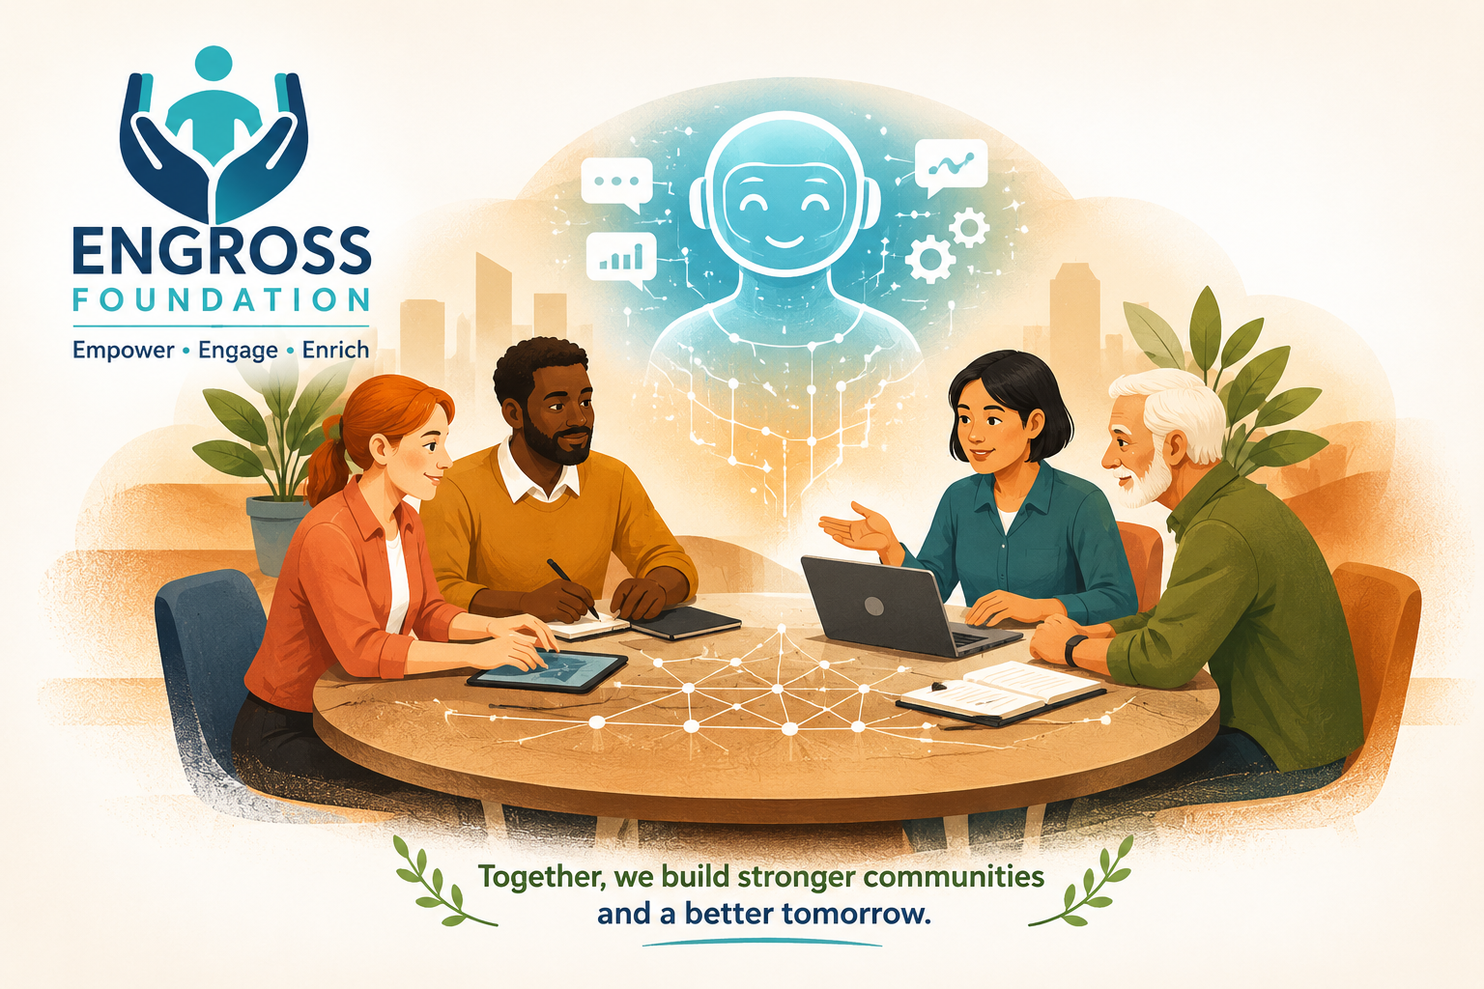

Join Us as an Intern and Enumerator
Be Part of Change. Contribute to Impact. Grow with Purpose.
At Engross Foundation, we invite dedicated individuals to join us as Members and Enumerators to strengthen our research, community outreach, and development initiatives. Your participation can help drive meaningful and measurable social change.
Join our network of committed individuals and professionals working together to create sustainable impact.
Role & Contributions:
- Support programme planning and implementation
- Participate in meetings, campaigns, and outreach
- Contribute ideas, expertise, and networks
- Represent the foundation in community initiatives
Who Can Apply:
Social workers, professionals, academicians, students, and individuals passionate about social development.
Play a key role in our research and impact assessment projects by collecting accurate and reliable field data.
Role & Responsibilities:
- Conduct household surveys and field interviews
- Collect and record data using digital/physical tools
- Assist in baseline, midline, and endline surveys
- Ensure quality and accuracy of data collection
Preferred Skills:
- Basic communication and interpersonal skills
- Familiarity with local communities and languages
- Willingness to travel for fieldwork
- Basic knowledge of mobile/data collection tools (preferred)

Why Join Engross Foundation?
• Gain hands-on experience in development sector projects
• Work with experienced researchers and professionals
• Enhance field, research, and leadership skills
• Receive certificates and recognition
• Contribute to meaningful social change
Option to Select Member / Enumerator
Name
State
District
Address
Highest Education
Skill and Interest
Attach Resume
Attach a Govt Issued ID
Automatic ID card create for Download with Validity – To be approved by Authority then create and Admin have write to add project name and validity in the in the I card.

Tab - Projects

Make Good and Presentable

Year | Project / Assignment | Nature / description of assignment
2026-27 | Evaluation of DTNBWED , Ministry of Labour and Empowerment | Assessment, Survey, Interviews, FGDs, Consultation with stakeholders etc. All India
2025-26 | Impact Assessment of HCL Foundation PRI Project | Impact Assessment, Survey, Interviews, FGDs, Consultation with stakeholders etc. Hardoi District UP
2025-26 | Monitoring of RD Schemes Ministry of Rural Development | Survey, Interviews, Monitoring, Assessment, Stakeholders consultation, Reports etc. 3 NE states and 14 districts
2025-26 | Impact Assessment of HCL Foundation Samuday Project | Impact Assessment, Survey, Interviews, FGDs, Consultation with stakeholders etc. Hardoi District UP Sample 4000+
2025-26 | Arunachal Pradesh Farmers Survey, NEDFI Guwahati | Survey, Interviews and Discussions etc.
2025-26 | Impact Study of Safi Sathi project UNDP Innervation | Impact Assessment, Survey, Interviews, FGDs, Consultation with stakeholders etc. States- Delhi/NCR, Karnataka, Andhra Pradesh and Maharashtra sample 4200+
2025-26 | Baseline Survey and study of FNHW Family, Nutrition Health and WASH ). West Bengal State Rural Livelihood Mission and UNDP | Survey of Adolescents girls, Pregnant women, Lacting mothers, Health Workers and officials involved in program implementation, Interviews, discussions, FGDs, Assessment Future interventions etc.  Districts of West Bengal Sample 4000
2025-26 | Skill Gap Study Textile Committee, Ministry of Textile Govt | Survey of Textile units, Handloom, Handicraft Workers, Interviews, FGDs, Interaction with various stakeholders, assessment of skills, All States and UTs PAN India Sample 5000+
2024-25 | Monitoring of the RD Schemes Ministry of Rural Development Govt of India | Survey / Verification / Monitoring and Reports  & District Maharashtra and Tripura
2024-25 | Impact Assessment and Evaluation of PMFME Scheme, Ministry of Food Processing Industries Govt of India | Manufacturing Units, SHGs, FPOs, Group Enterprises, Business Establishments Survey. 32 States PAN India
2024-25 | Monitoring of the RD Schemes, Ministry of Rural Development Govt of India | Survey / Verification / Monitoring and Reports  & District UP
2023-24 | Survey & Study on Tea Consumption in India, Tea Board Kolkata, Ministry of Industry and Commerce, Govt of India | Households and Business Establishments Survey. 17 States, Sample 10000
2023-24 | Complaint / Inquiry on PMAY-G, Ministry of Rural Development Govt of India | Inquiry / Verification and Report  Akola District Maharastra

